# Beginning

## What is Web API

* It is a framework that helps us to build or deploy the services of HTTP

## What is content negotiation in ASP.Net Web API?

* One of the standards of the RESTful service is that the client should have the ability to decide in which format they want the response - XML, JSON etc  A request that is sent to the server includes an Accept header. Using the Accept header the client can specify the format for the response.

For example

Accept: application/xml returns XML  
Accept: application/json returns JSON  
  
**Depending on the Accept header value in the request, the server sends the response. This is called Content Negotiation.**

* When the response is being sent to the client in the requested format, notice that the Content-Type header of the response is set to the appropriate value. For example, if the client has requested application/xml, the server send the data in XML format and also sets the Content-Type=application/xml.
* The formatters are used by the server for both request and response messages. When the client sends a request to the server, we set the Content-Type header to the appropriate value to let the server know the format of the data that we are sending. For example, if the client is sending JSON data, the Content-Type header is set to application/json. The server knows it is dealing with JSON data, so it uses JSON formatter to convert JSON data to .NET Type. **Similarly** when a response is being sent from the server to the client, depending on the Accept header value, the appropriate formatter is used to convert .NET type to JSON, XML etc.
* it chooses the best media type formatters (based on Accept header in incoming request) to **return a response to an incoming request**
* content negotiation is done at the server-side
* ASP.NET Web API is greatly extensible. This means we can also plugin our own formatters, for custom formatting the data.
* <https://csharp-video-tutorials.blogspot.com/2016/09/aspnet-web-api-content-negotiation.html>

## Explain media type formatters.

* <https://csharp-video-tutorials.blogspot.com/2016/09/aspnet-web-api-mediatypeformatter.html>
* MediaTypeFormatter is an abstract class from which JsonMediaTypeFormatter and XmlMediaTypeFormatter classes inherit from
* JsonMediaTypeFormatter handles JSON and XmlMediaTypeFormatter handles XML.
* In web API, media type formatters are classes that are responsible for **serialization data**
* serialization generally means a process of translating data into a format that can be transmitted and reconstructed later
* understand request data format in a better way and send data in a format that the client expects
* These are classes that are responsible for response data. The Web API understands the request data format as well as sends data in the format as expected by the clients.
* Json.NET library is generally used by Web API for JSON serialization
* Web API generally supports only HTTP protocol.

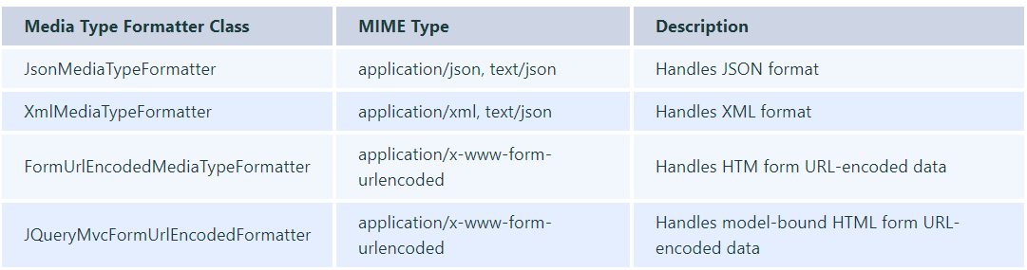

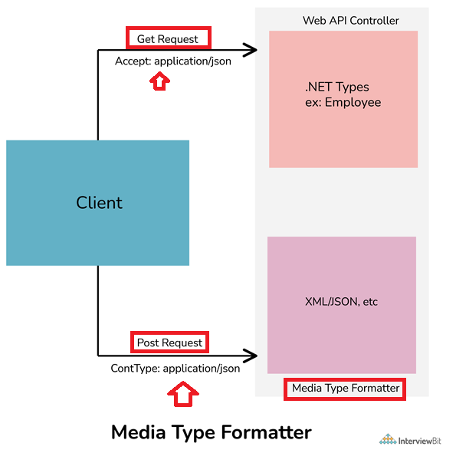

## advantages that you could speak about Web API?

* Content Negotiation,
* routing, and
* model bindings are some of the top picks that one could say when it comes to the advantages of Web API.

## What is ASP.Net Web API routing?

* Attribute based routing
* Convention based routing

## Difference between HTTP GET vs HTTP Post?

* 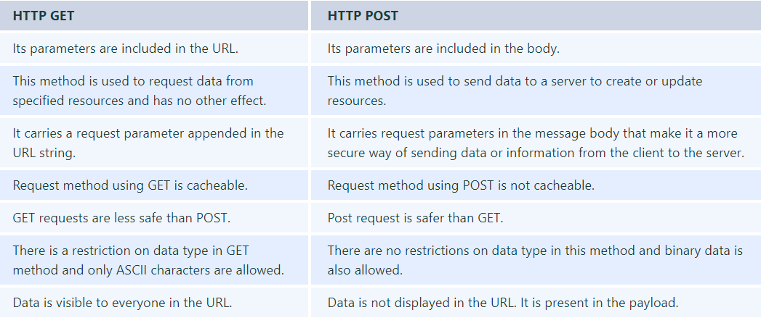

## What is CORS in Web API?

* CORS (Cross-Origin Resource Sharing)
* allows one to make requests from one website to another website in a browser that is normally not allowed by another policy called SOP (Same Origin Policy)

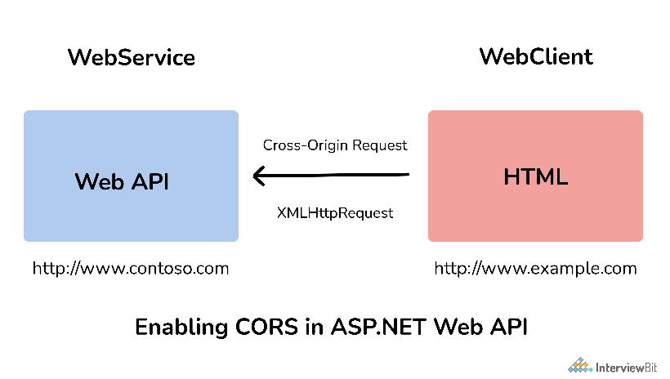

## What are Web API filters?

* **Authentication Filter:**
  + It handles authentication and authenticates HTTP requests.
  + It also helps to authenticate user detail. It checks the identity of the user.
* **Authorization Filter:**
  1. It handles authorization.
  2. It runs before controller action.
  3. This filter is used to check whether or not a user is authenticated.
  4. If the user is not authenticated, then it returns an HTTP status code 401 without invoking the action.
* **AuthorizeAttribute** is a built-in authorization filter provided by Web API.
* **Action Filter**: It is attributing that one can apply to controller action or entire controller. It is used to add extra logic before or after controller action executes. It is simply a way to add extra functionality to Web API services.
* **Exception Filter**: It is used to handle exceptions that are unhandled in Web API. It is used whenever controller actions throw an unhandled exception that is not HttpResponseException. It will implement an “IExceptionFilter” interface.
* **Override Filter**: It is used to exclude specific action methods or controllers from the global filter or controller level filter. It is simply used to modify the behavior of other filters for individual action methods.

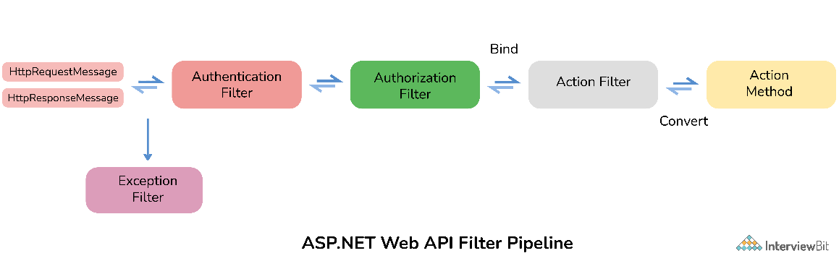

## What are new features used in ASP.NET Web API 2.0

ASP.NET Web API includes a number of new exciting features as given below:

* Attribute Routing
* CORS (Cross-Origin Resource Sharing)
* OWIN (Open Web Interface for .NET) self-hosting
* IHttpActionResult
* Web API OData

## What are the main return types supported in ASP. Net Web API?

It supports the following return types:

* HttpResponseMessage
* IHttpActionResult
* Void
* Other types such as string, int, etc.

## What is ASP.NET Web API routing?

* Routing is a way how Web API matches a URI to an action
* decides which action and controller should be called
* All public methods of controllers are basically known as action methods or just actions.

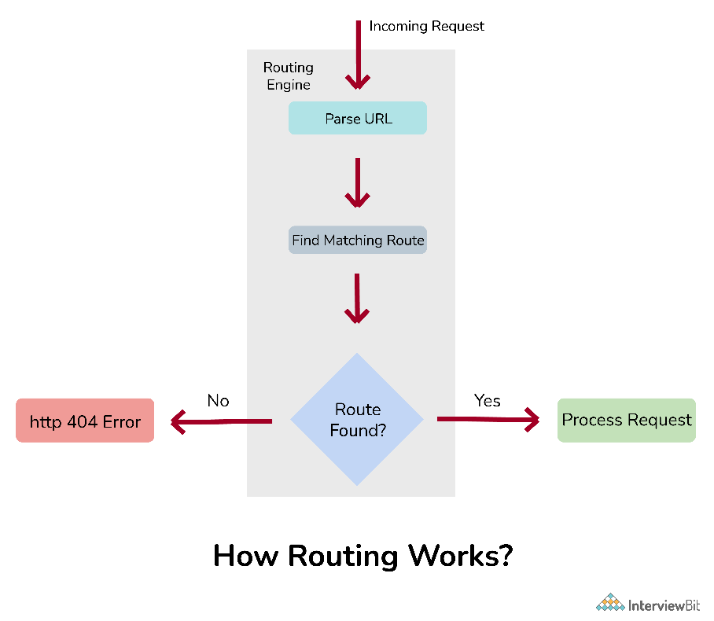

# Intermediate

# Advanced

# Microservice –

## Two communication style

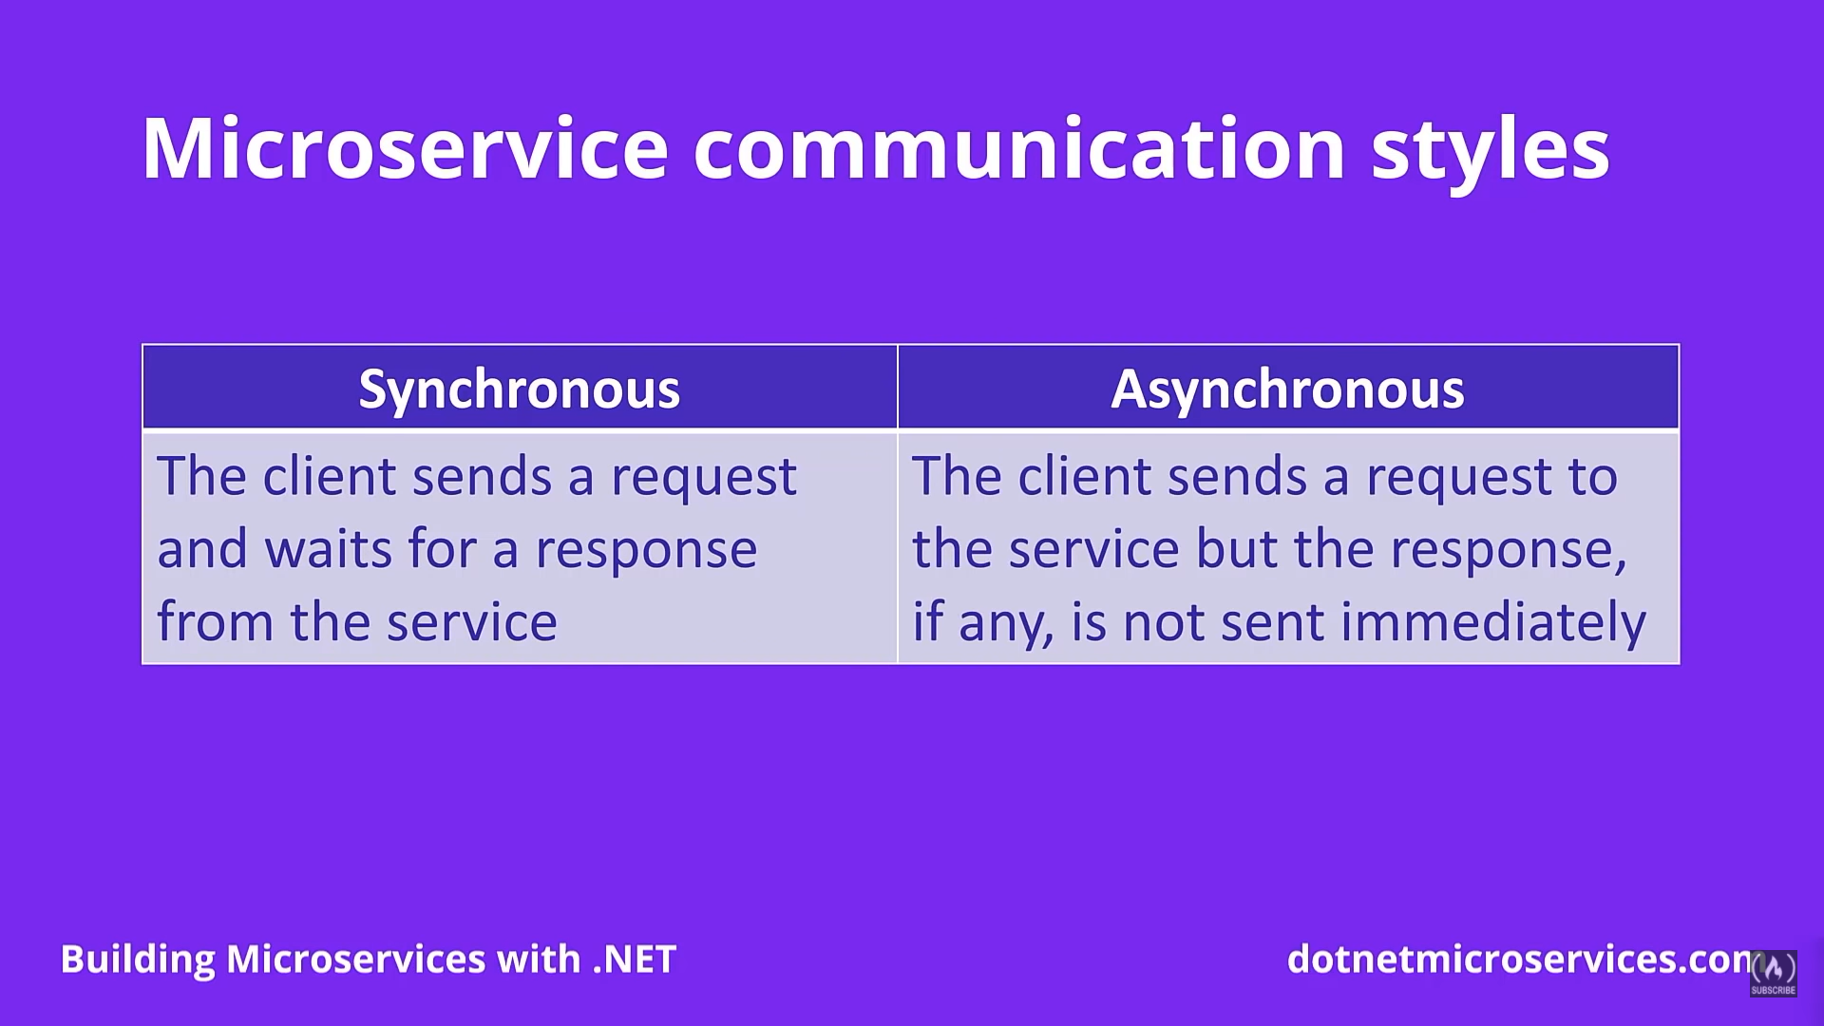

## **Synchronous Communication style**

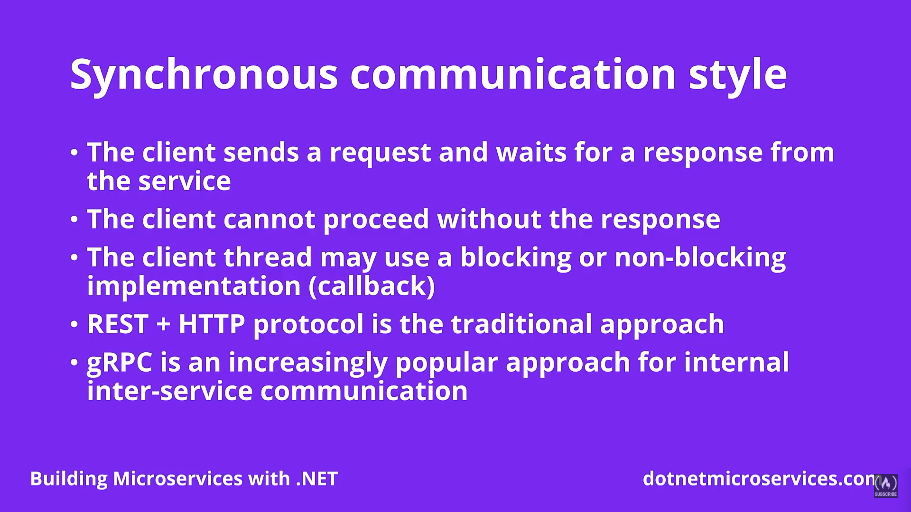

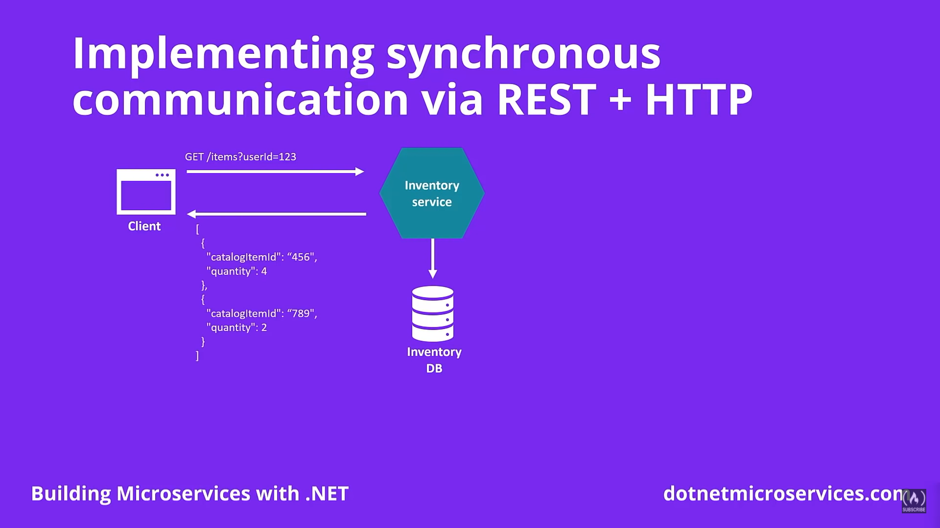

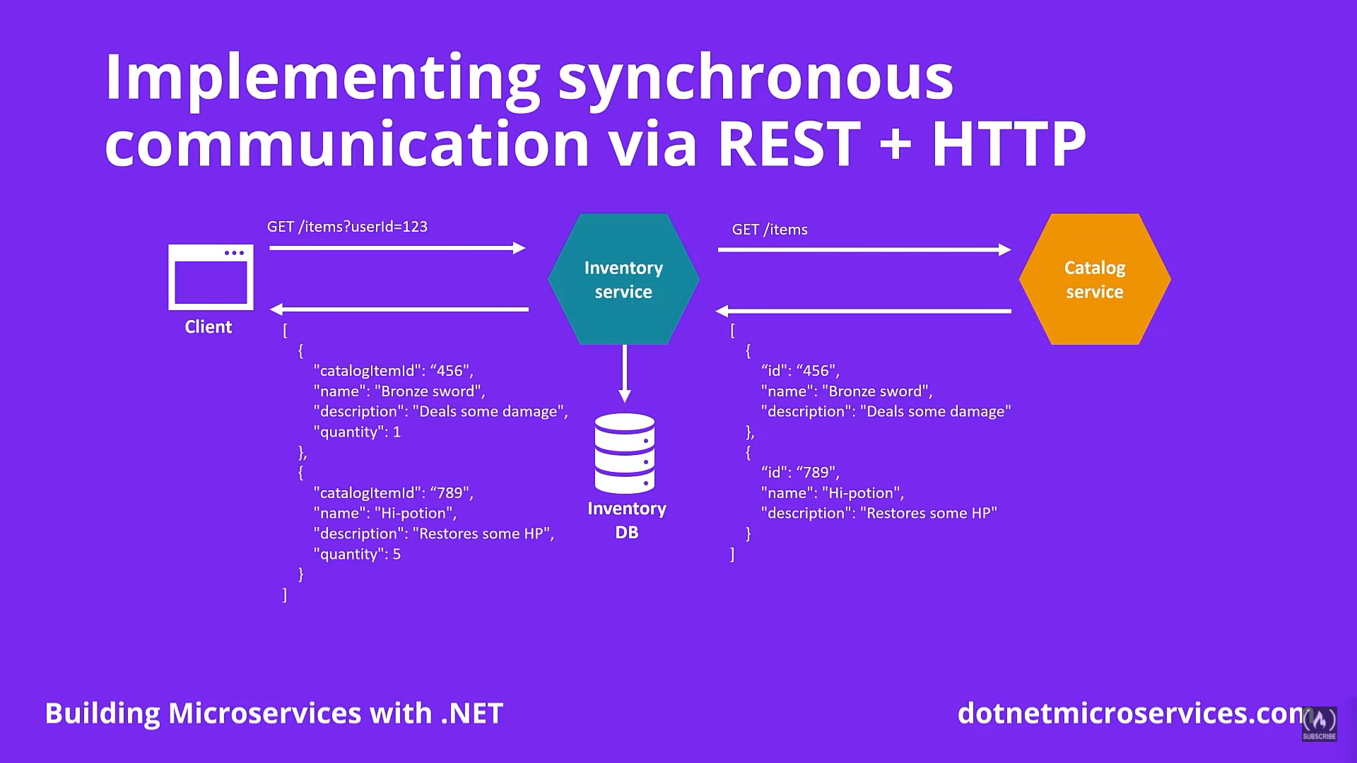

### Practical implementation of synchronous communication

**First – create client**

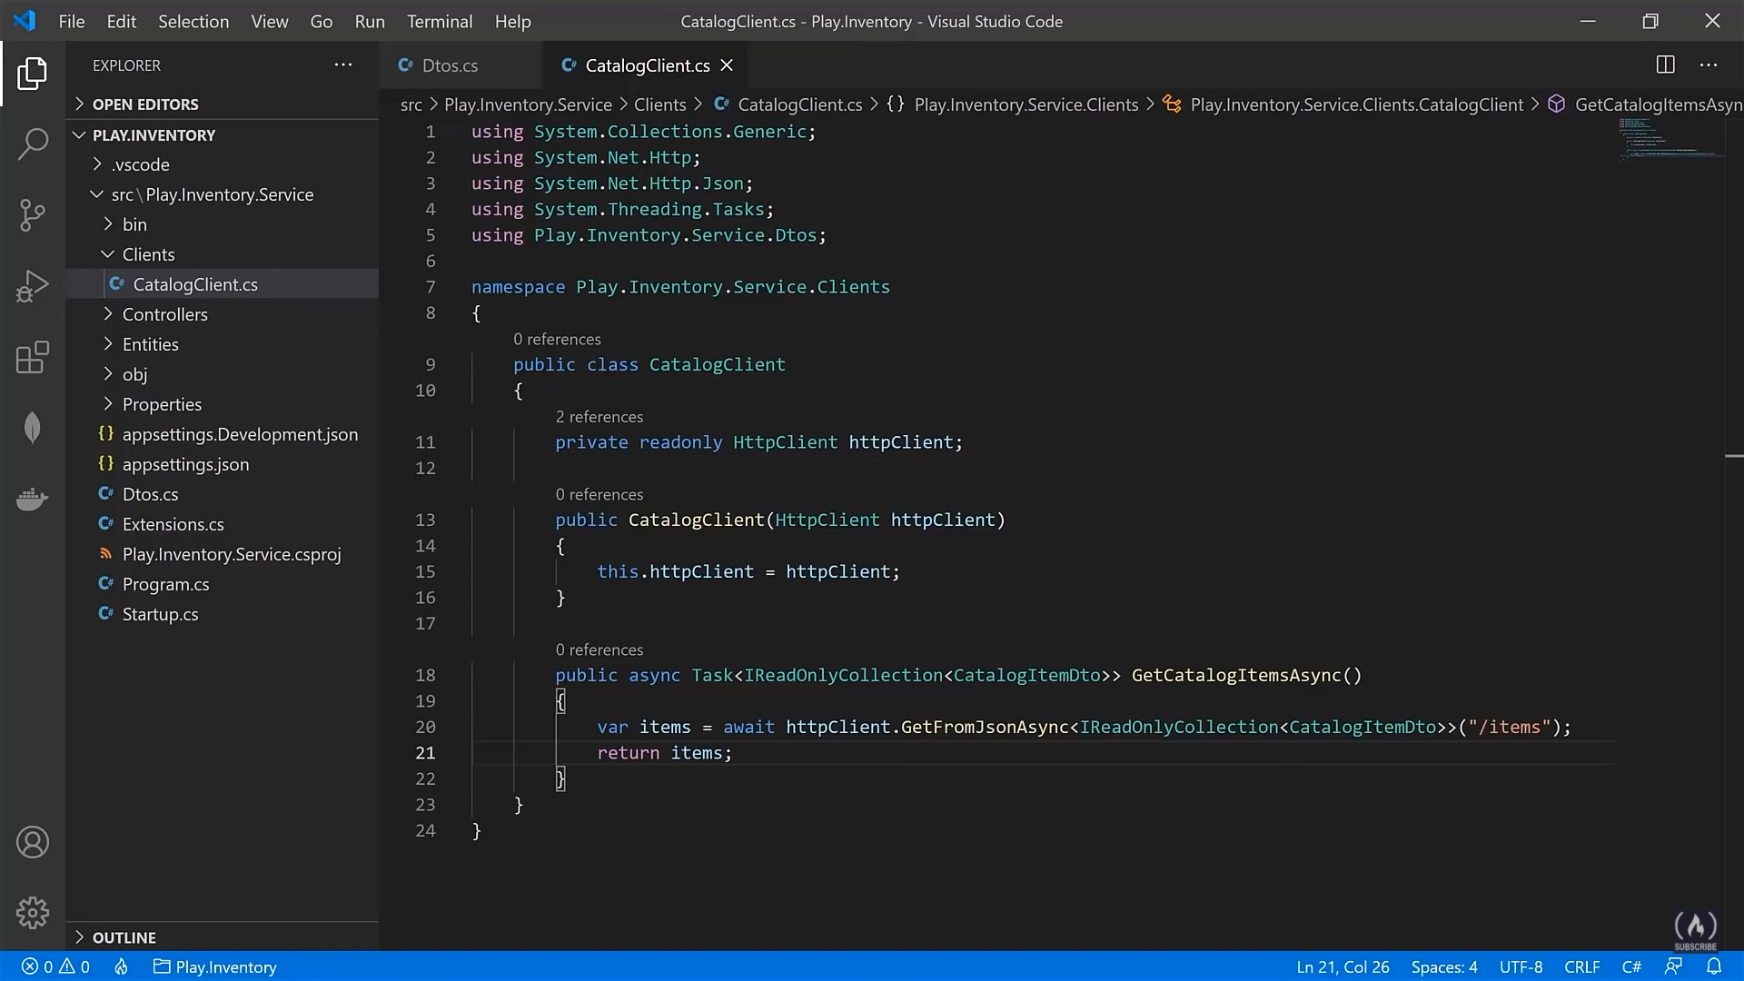

Second – register the client in start up

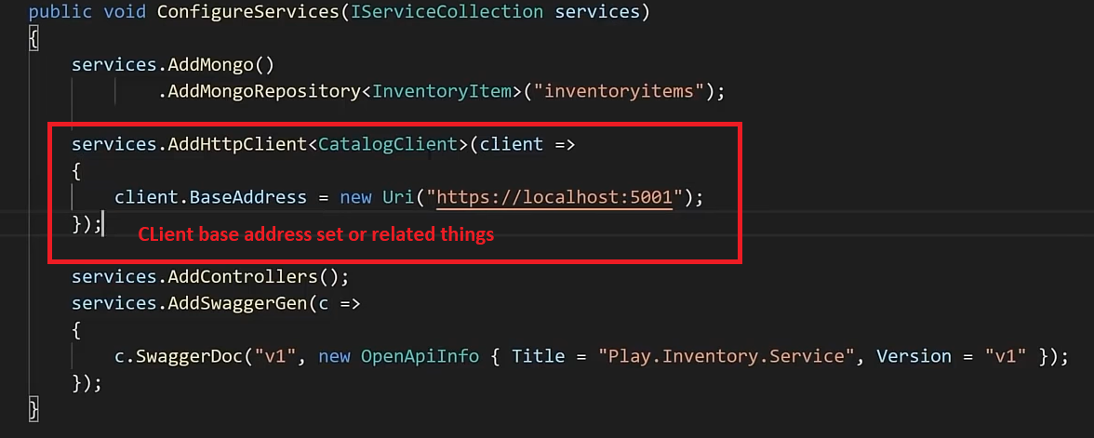

### **Handling Timeout in synchronous microservice communication**

<https://www.youtube.com/watch?v=CqCDOosvZIk>

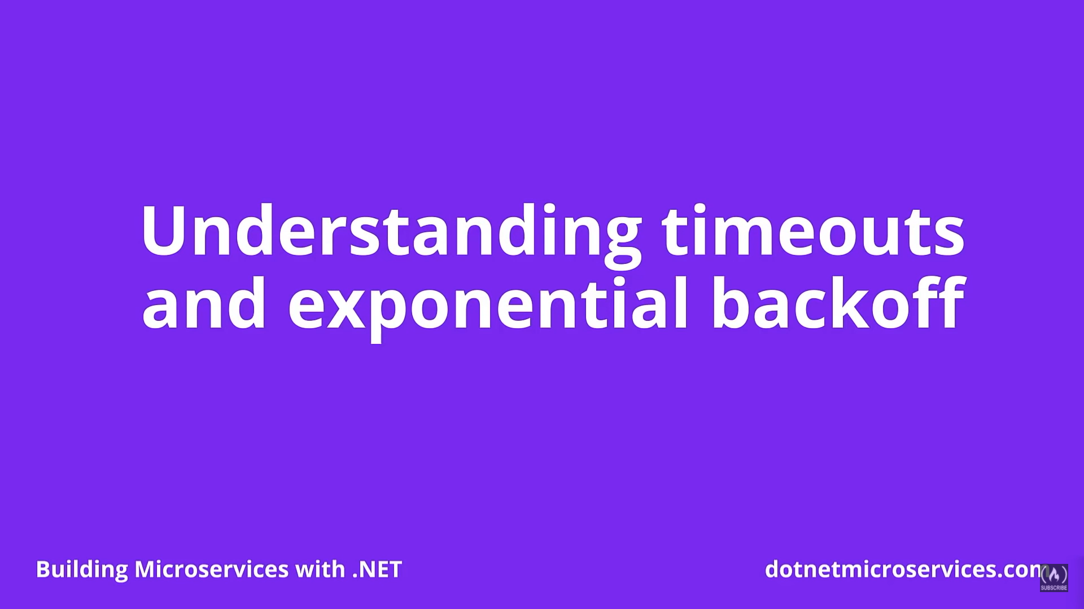

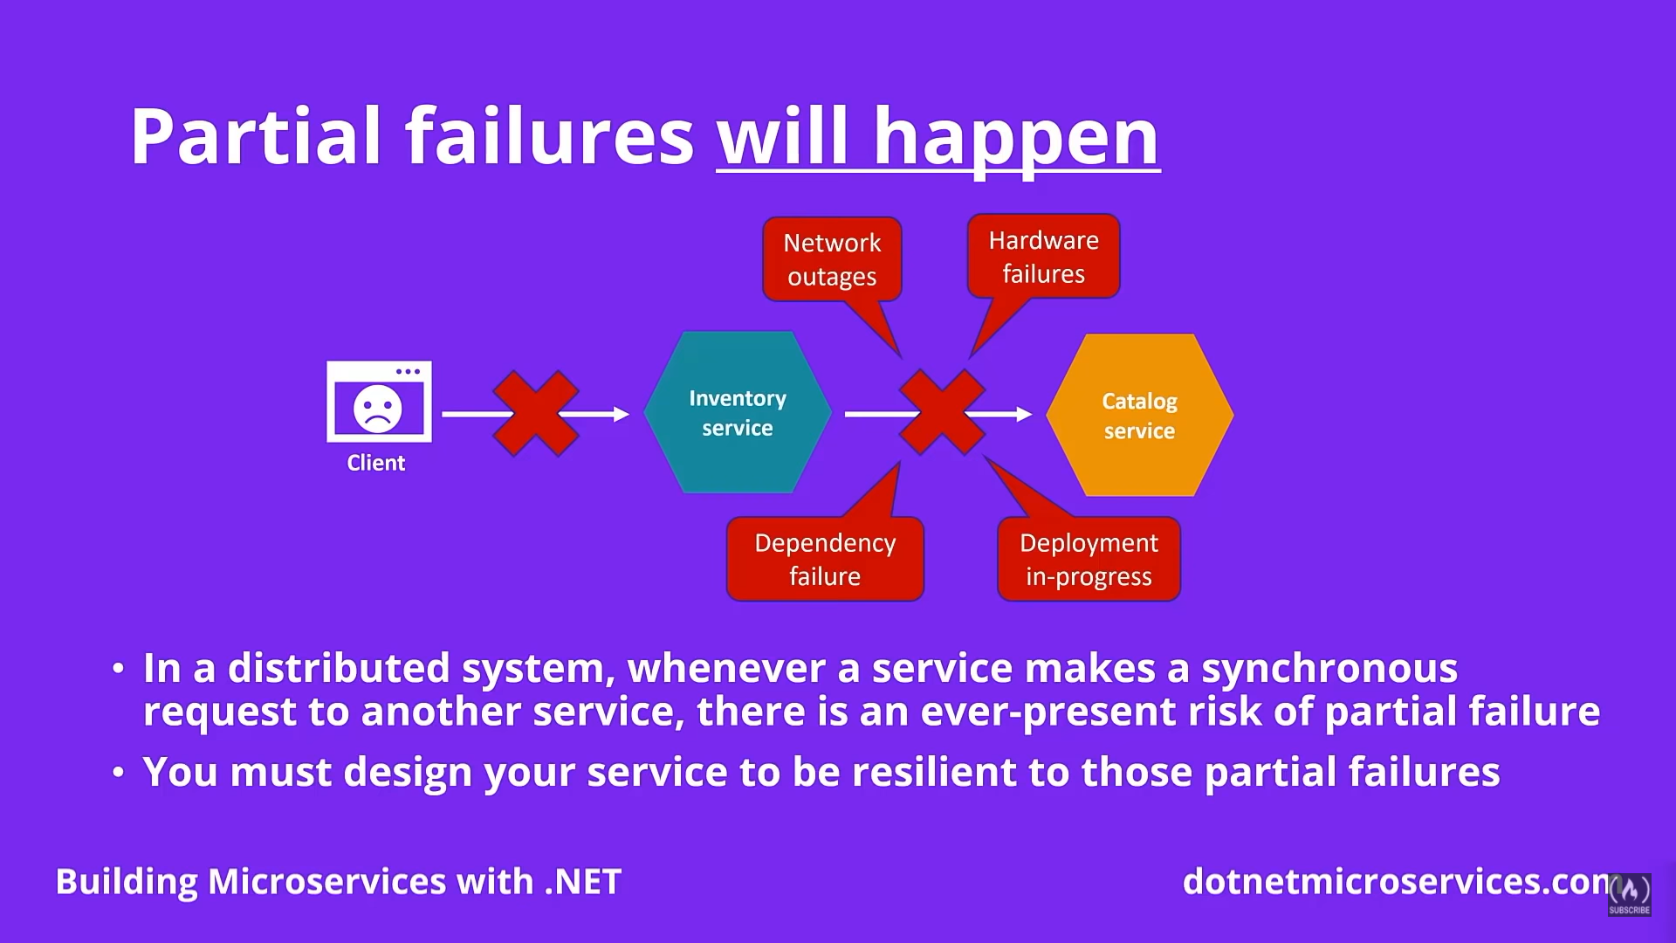

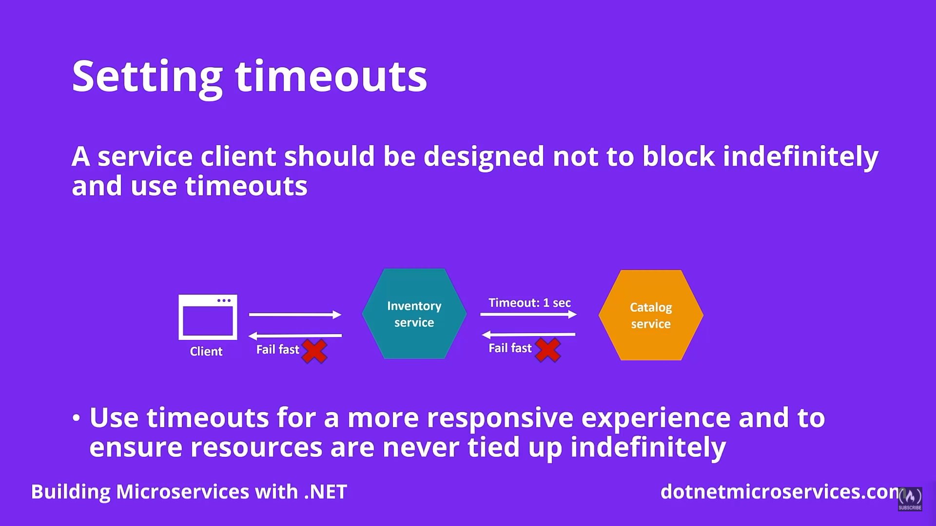

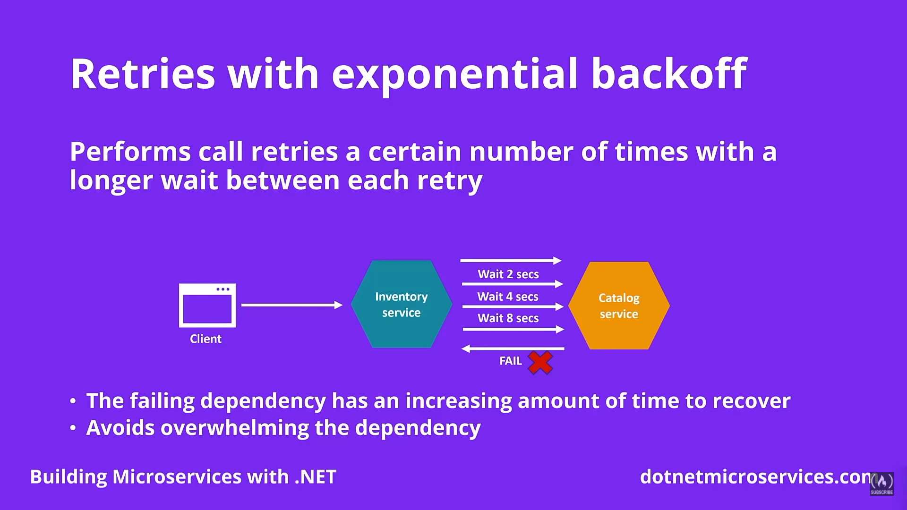

#### Practical Implementation

1. Install Polly

s

1. Start up configuration to handle timeout

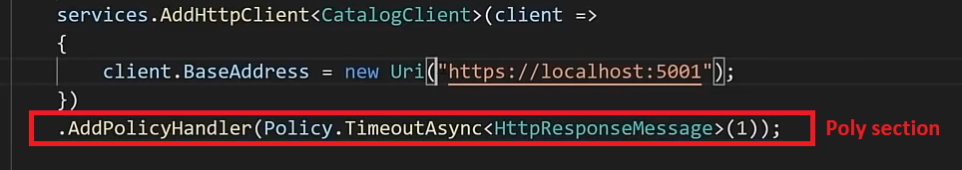

1. Retry setting using polly
2. 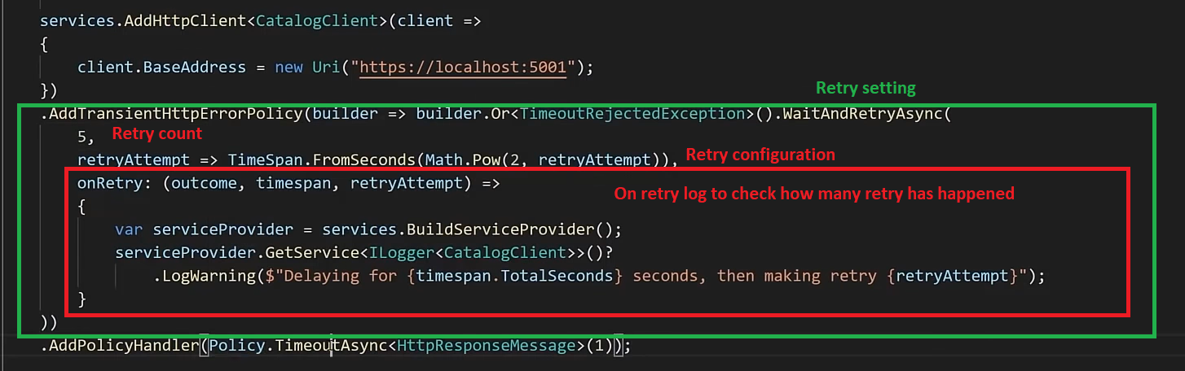

<https://www.youtube.com/watch?v=CqCDOosvZIk>

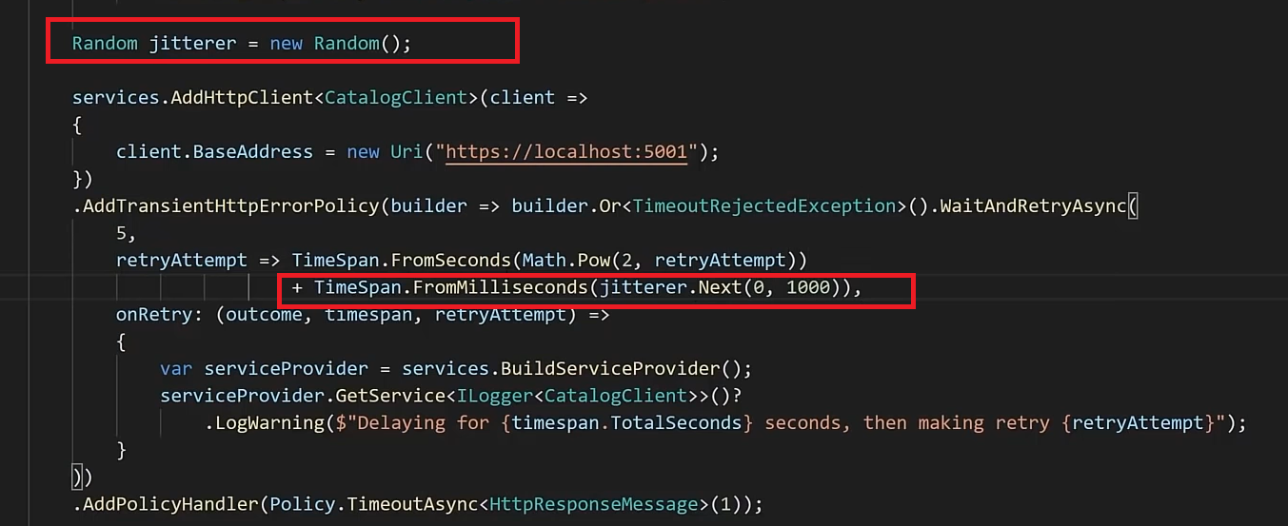

### Circuit breaker pattern

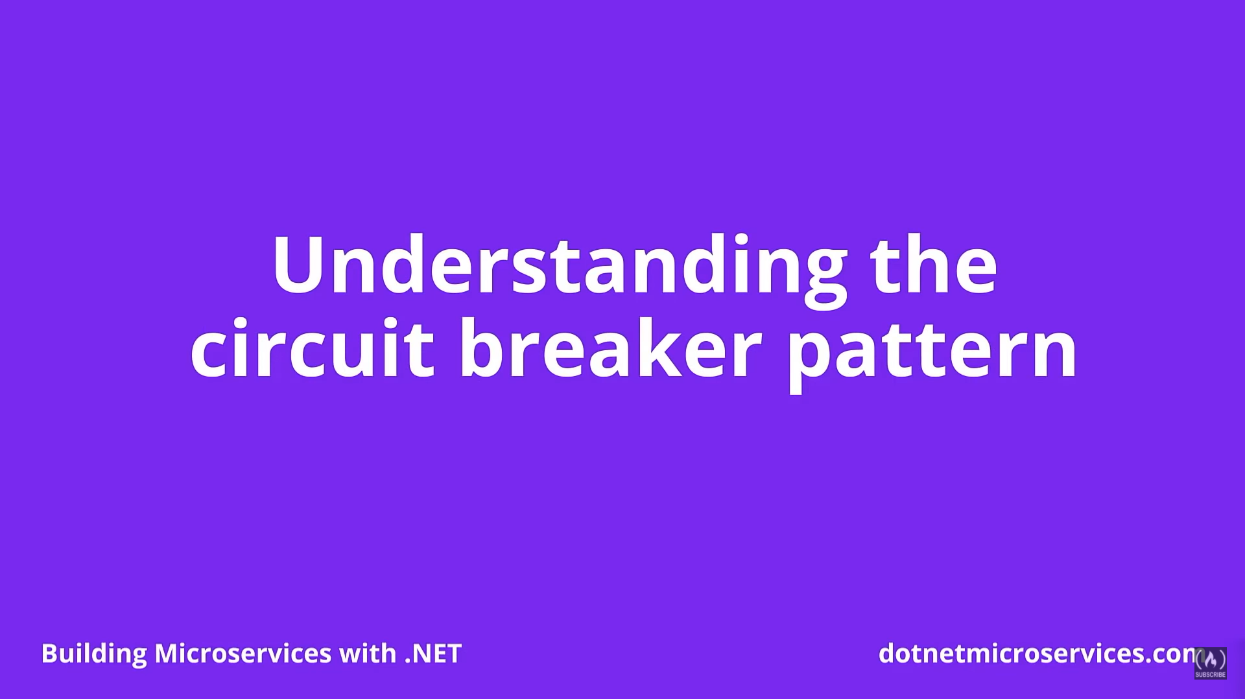

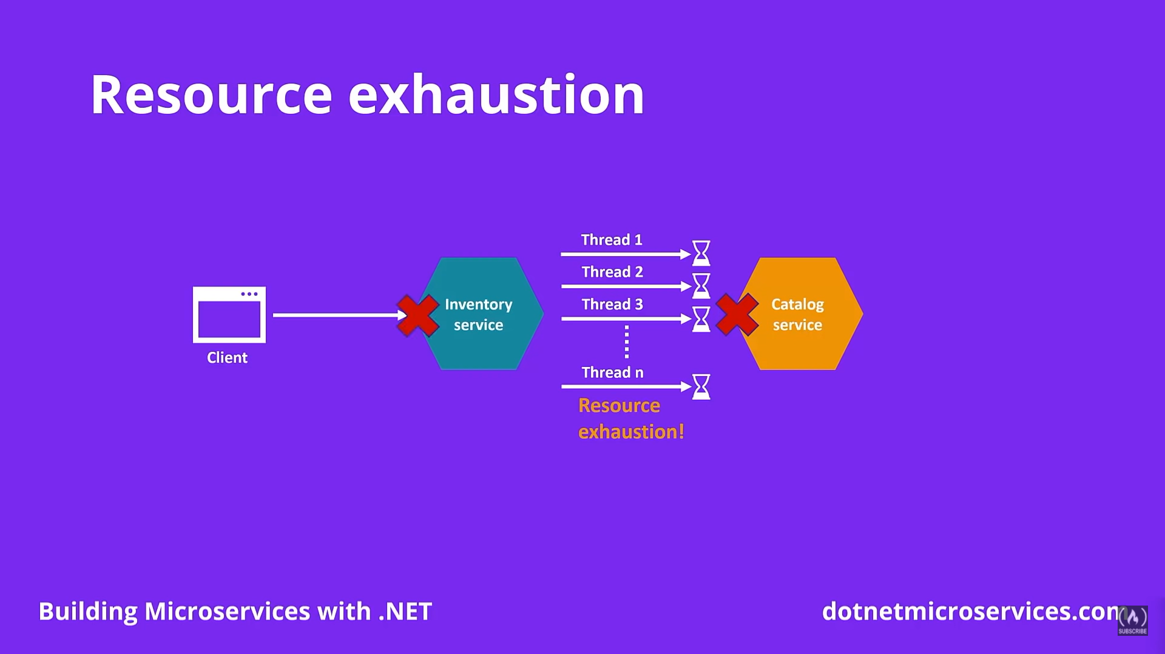

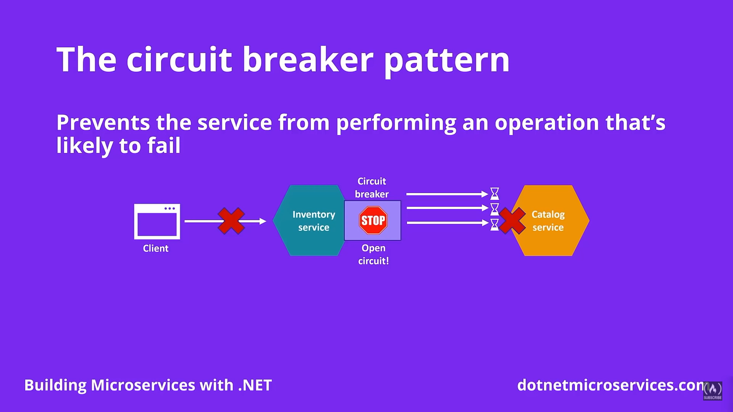

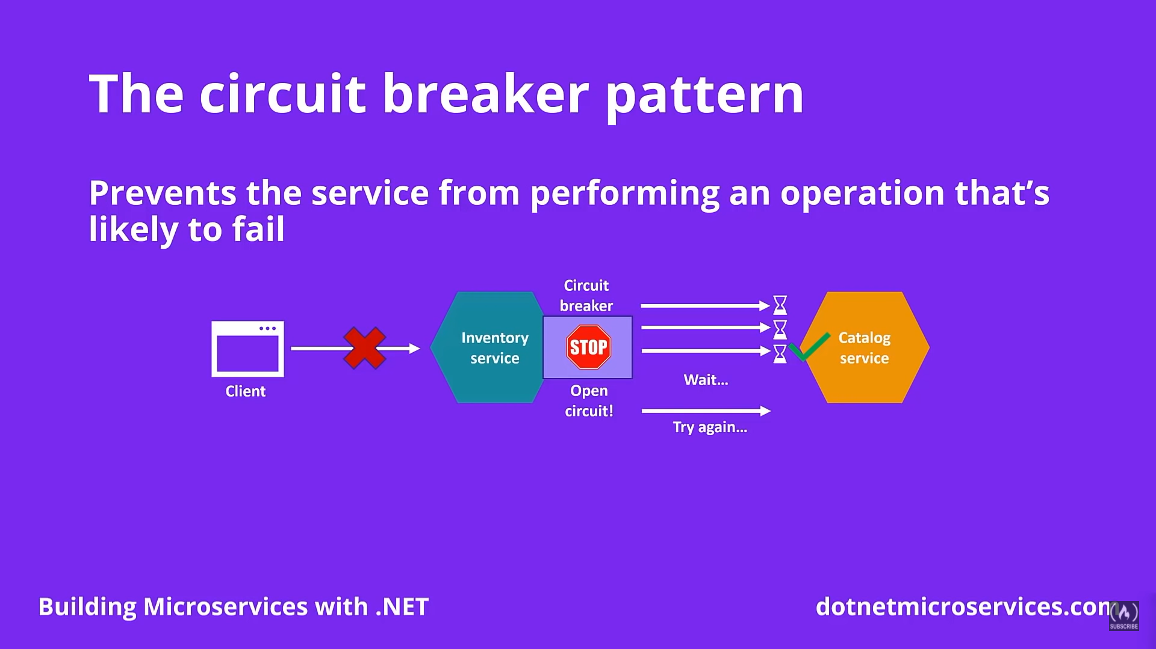

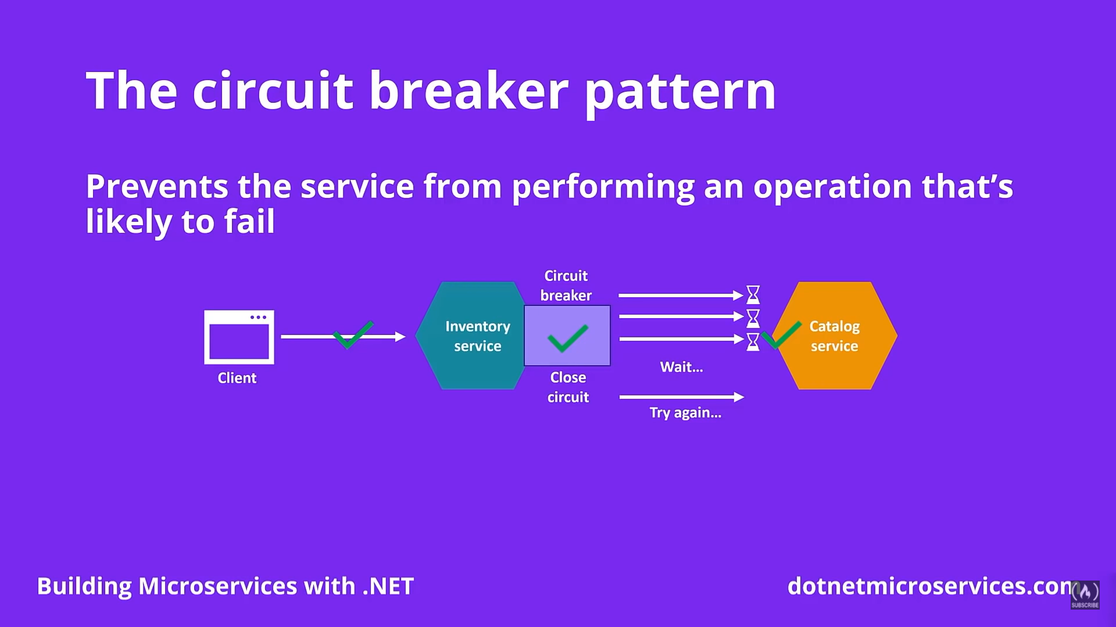

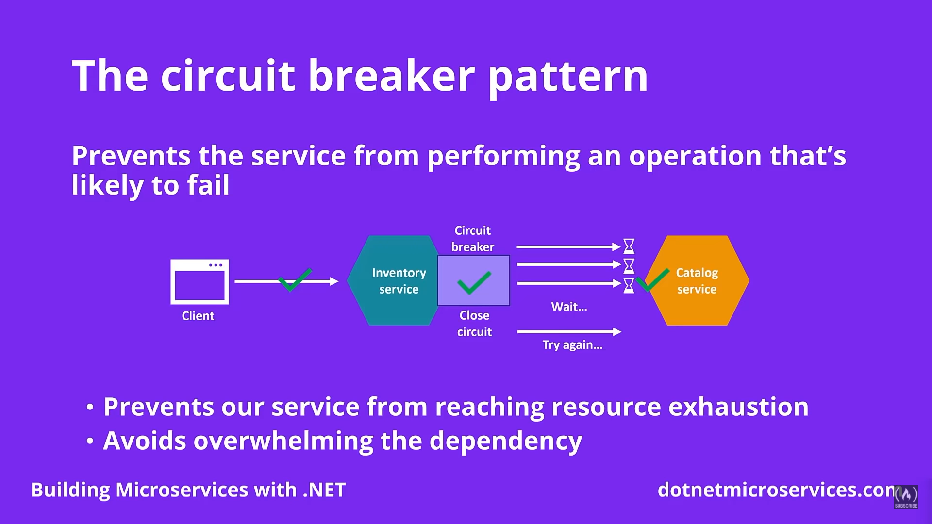

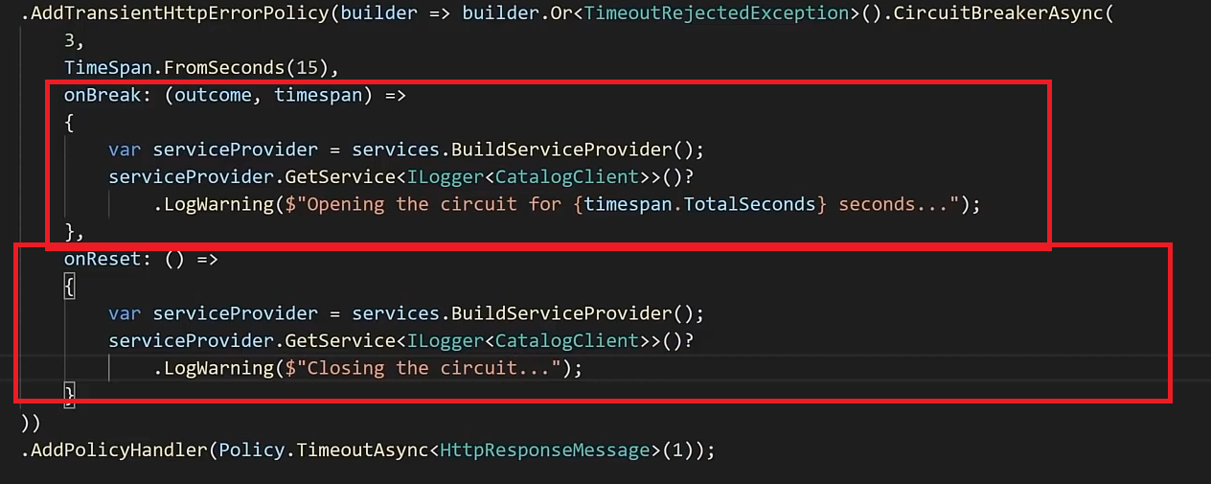

## Module 6- Asynchronous inter-service communication

### **Introduction to asynchronous communication**

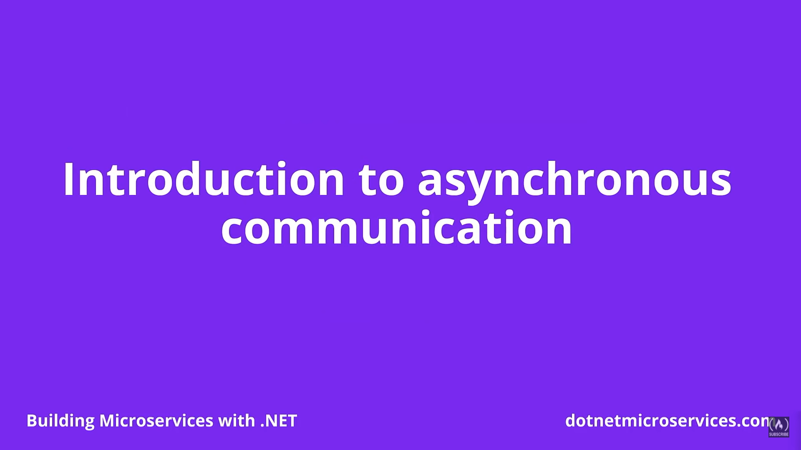

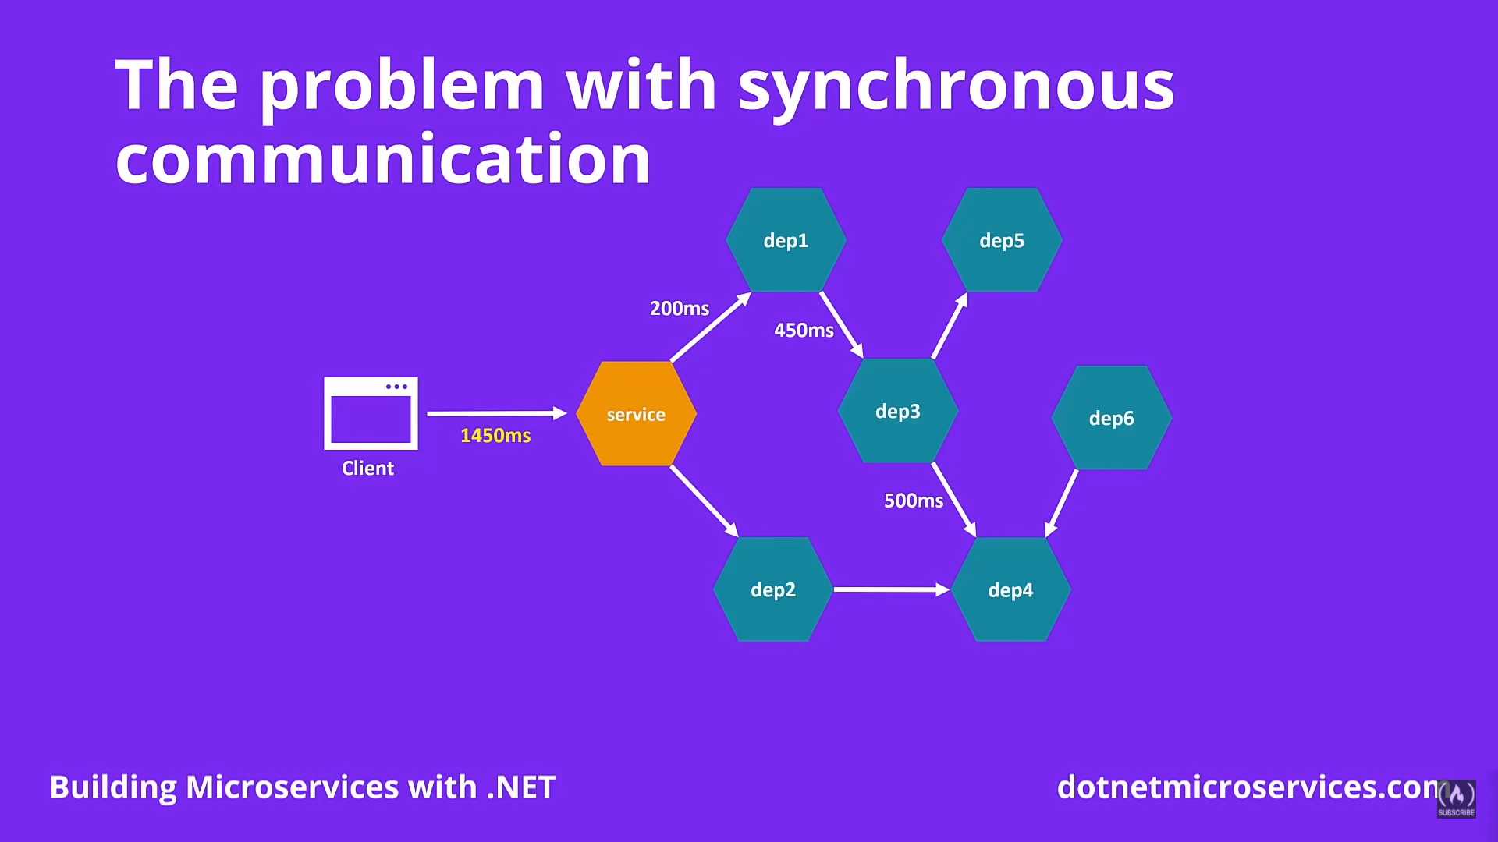

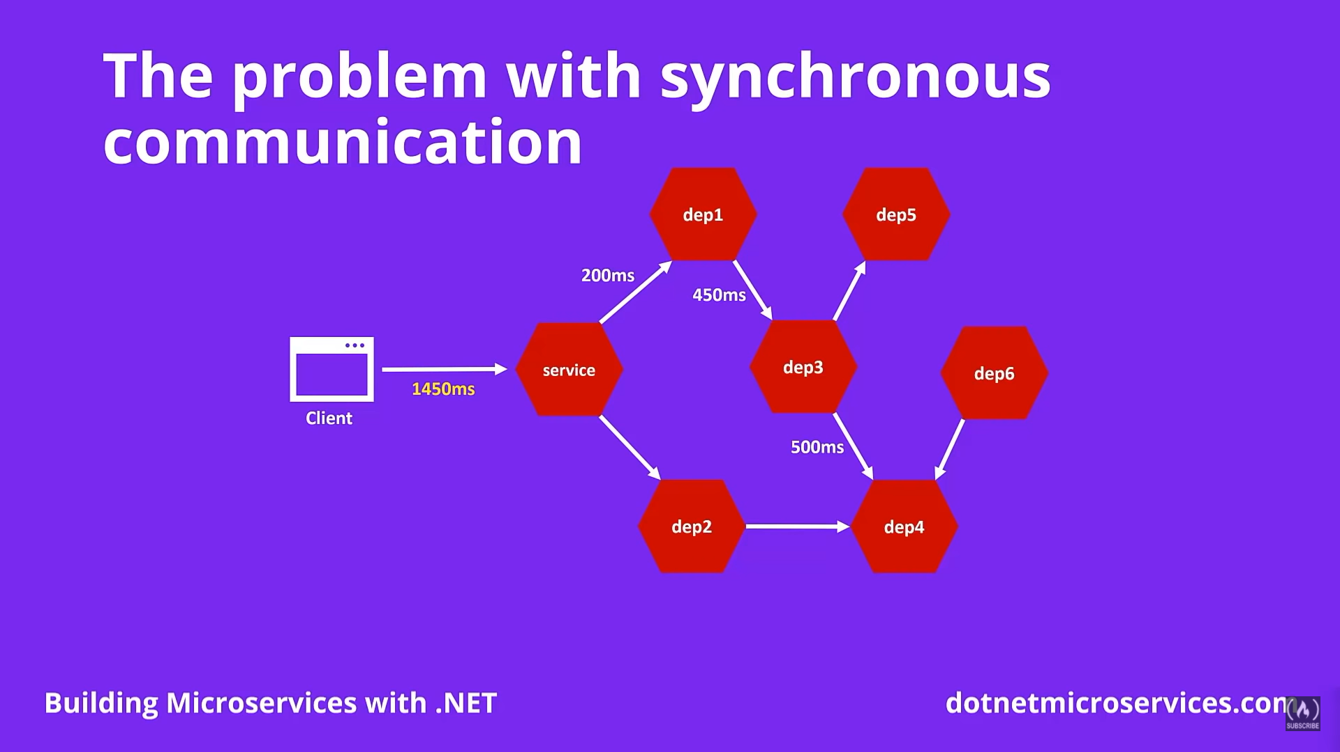

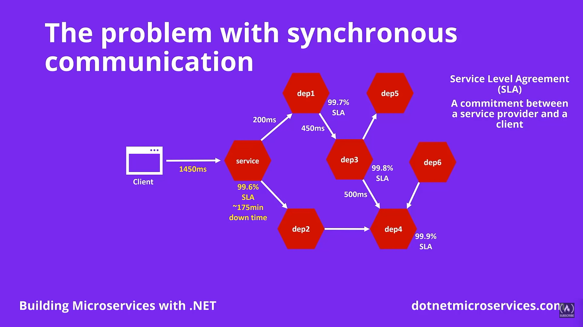

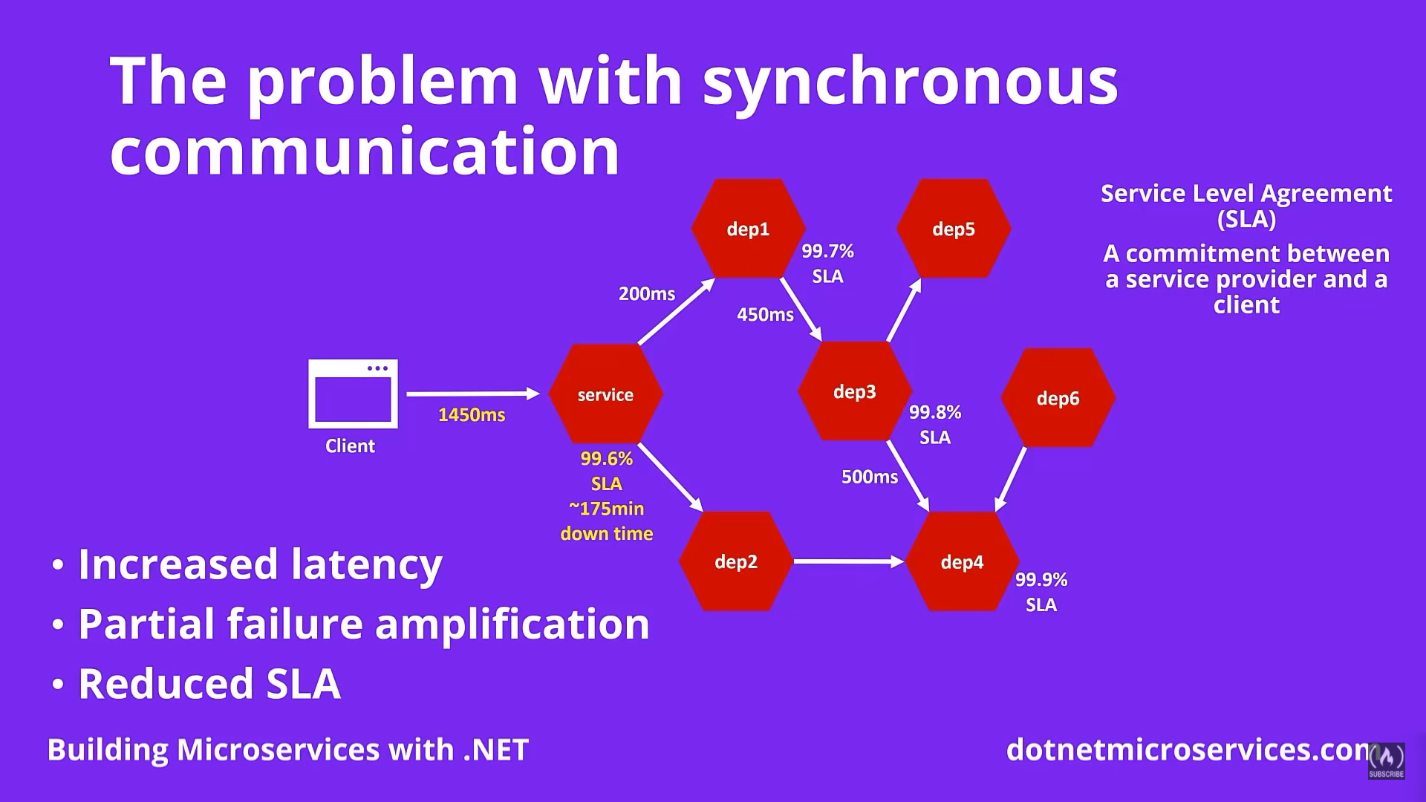

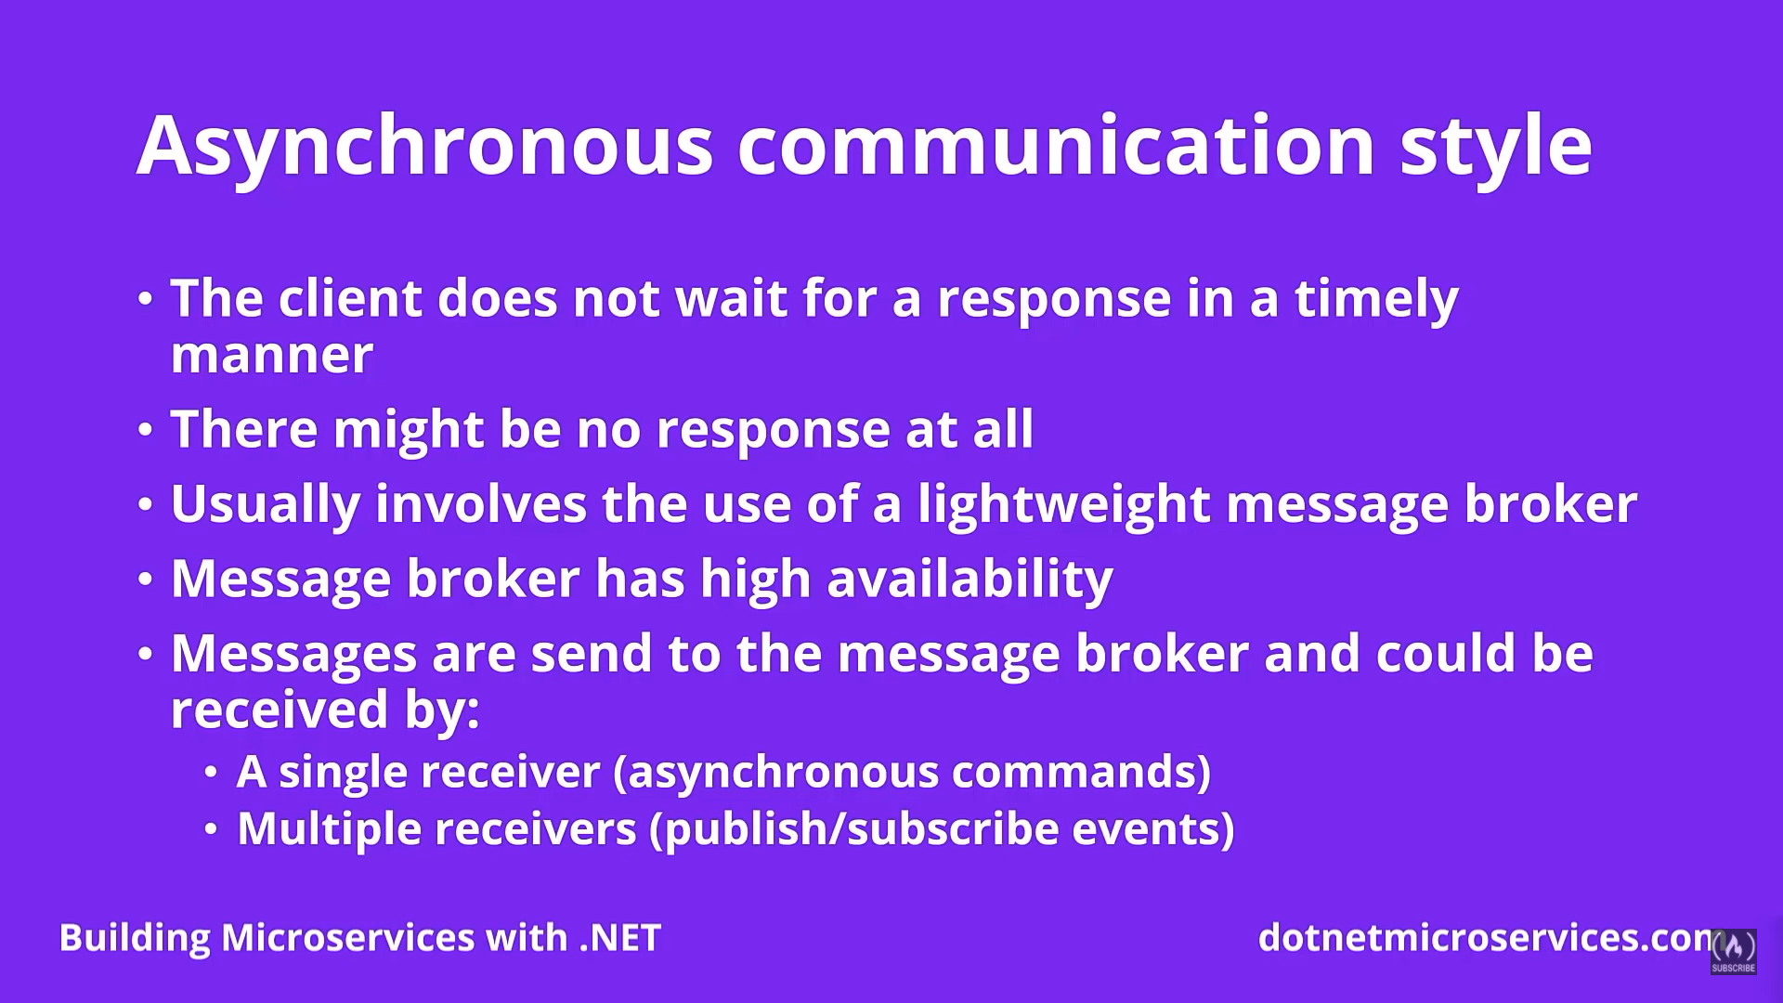

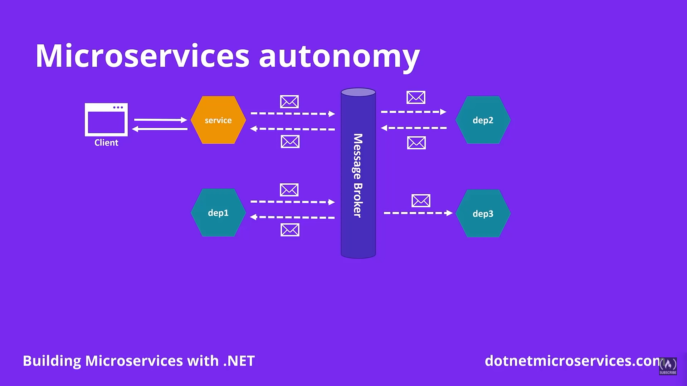

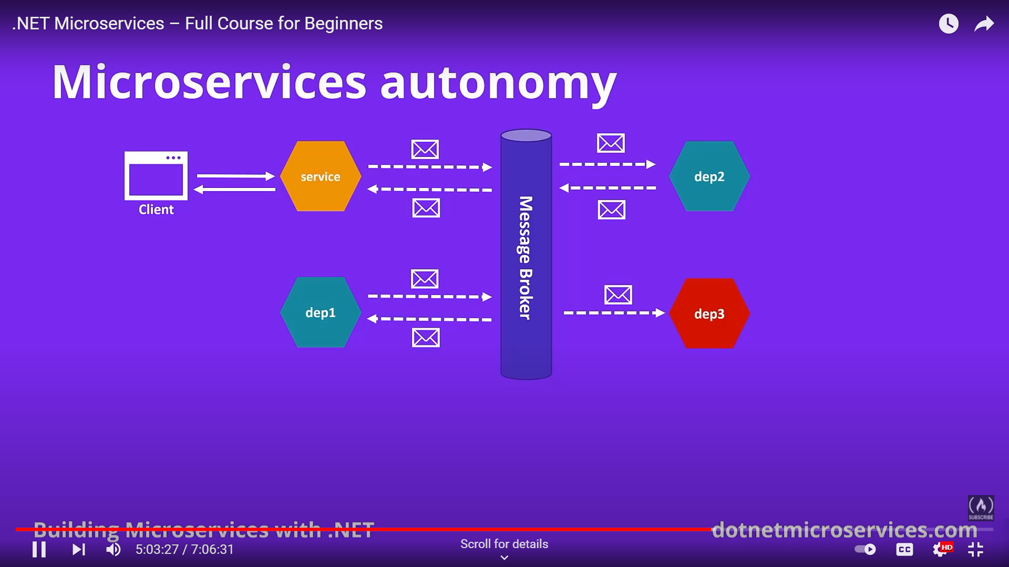

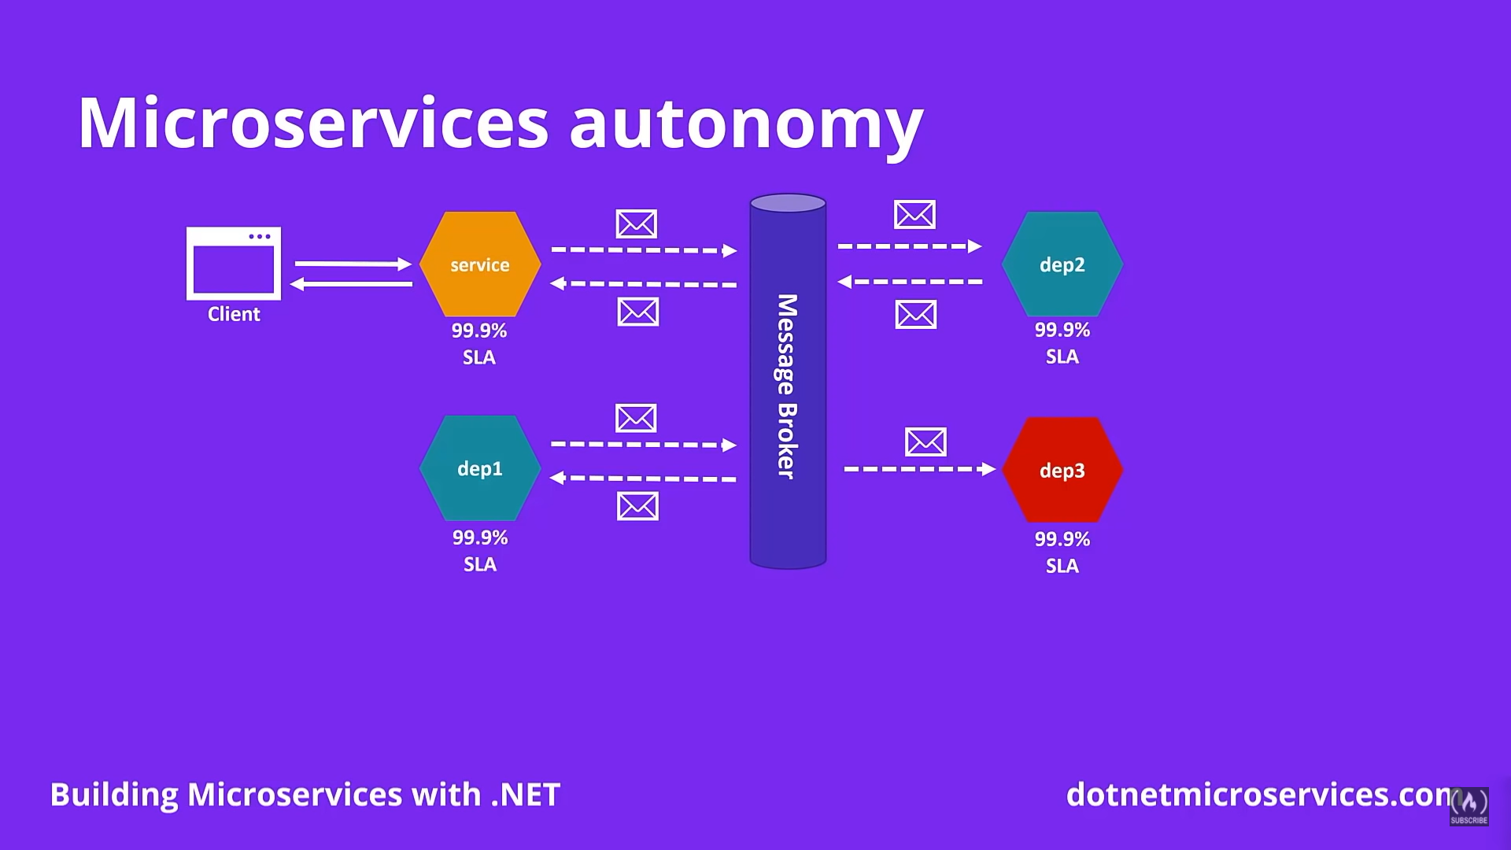

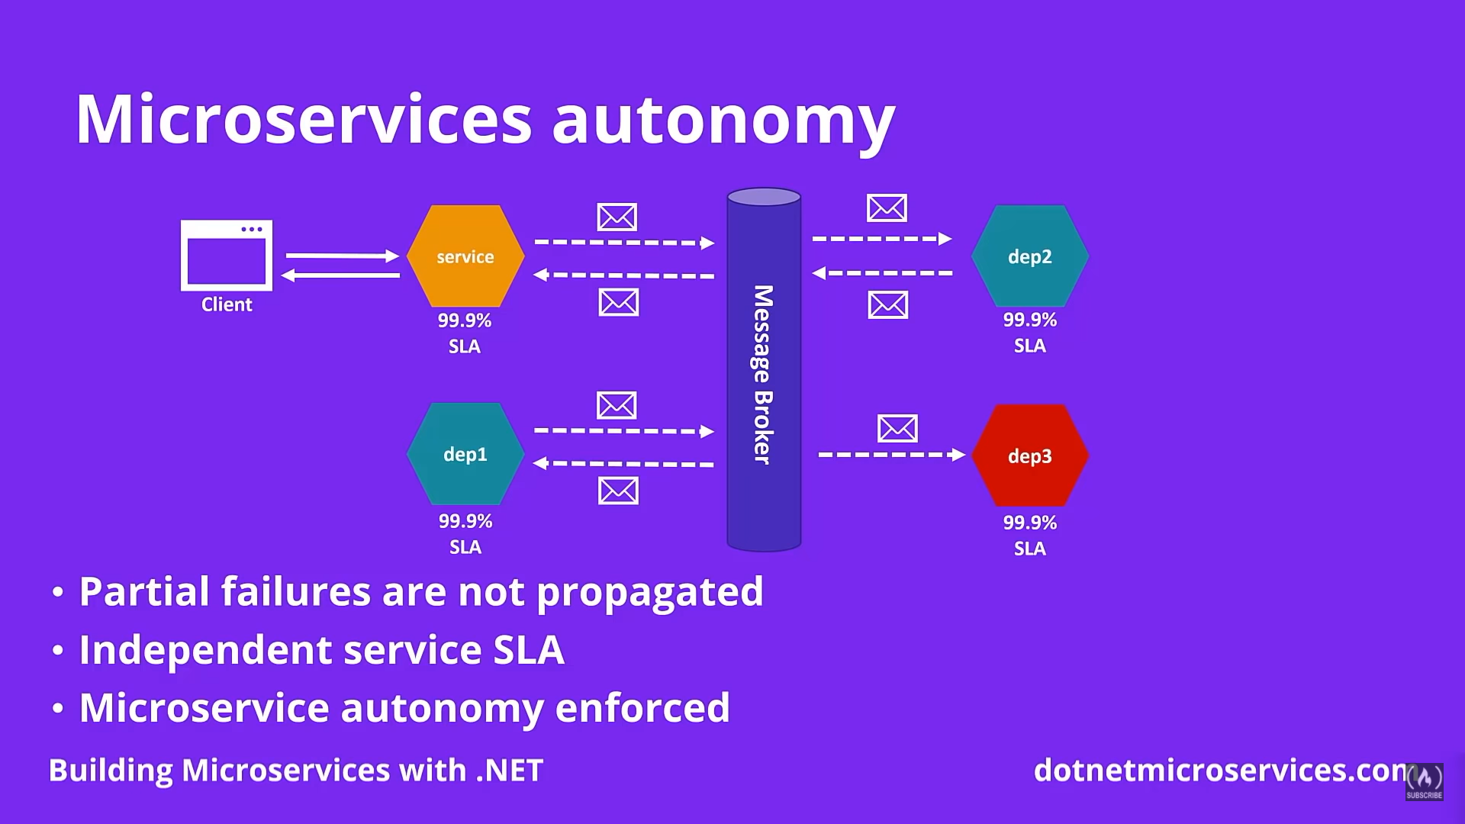

Asynchross propagation of data

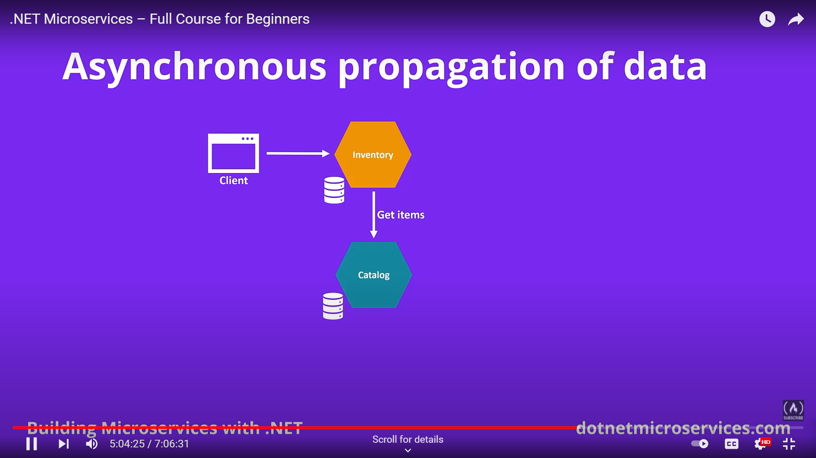

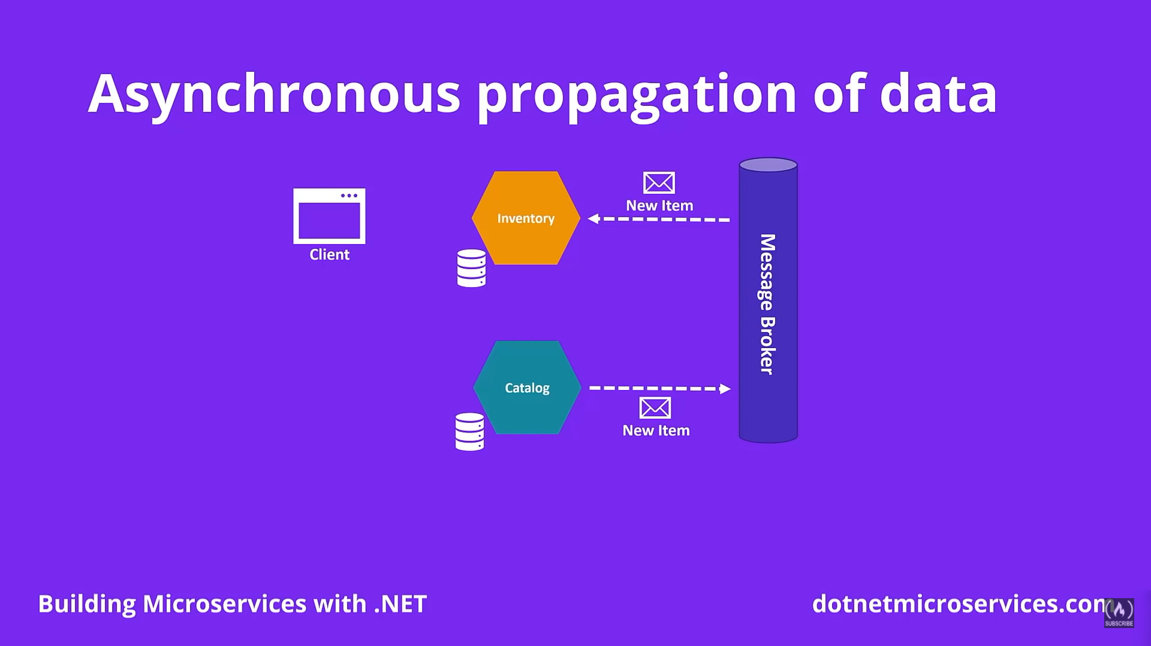

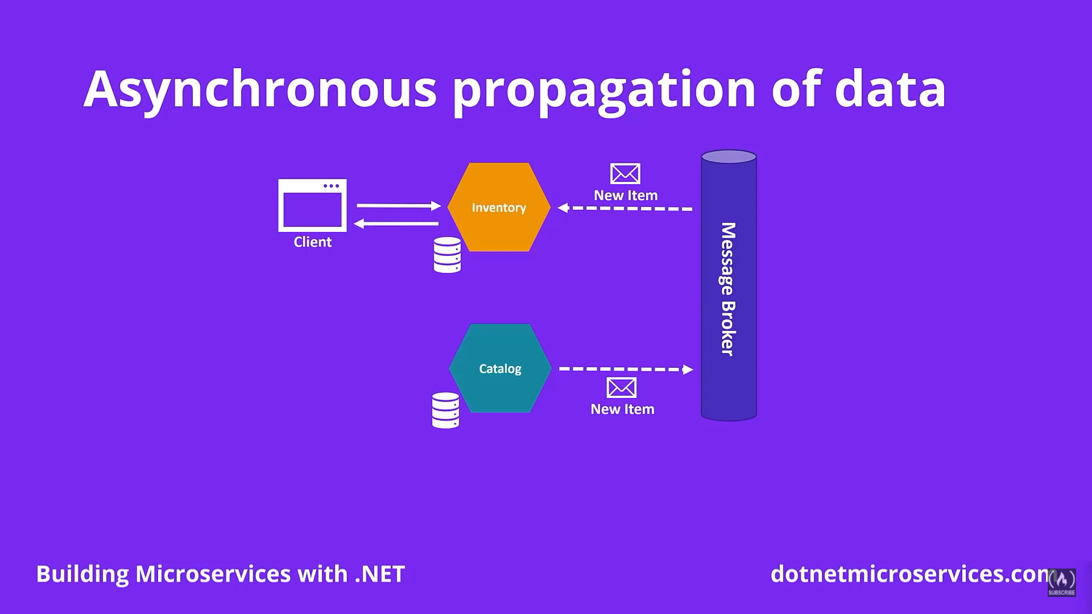

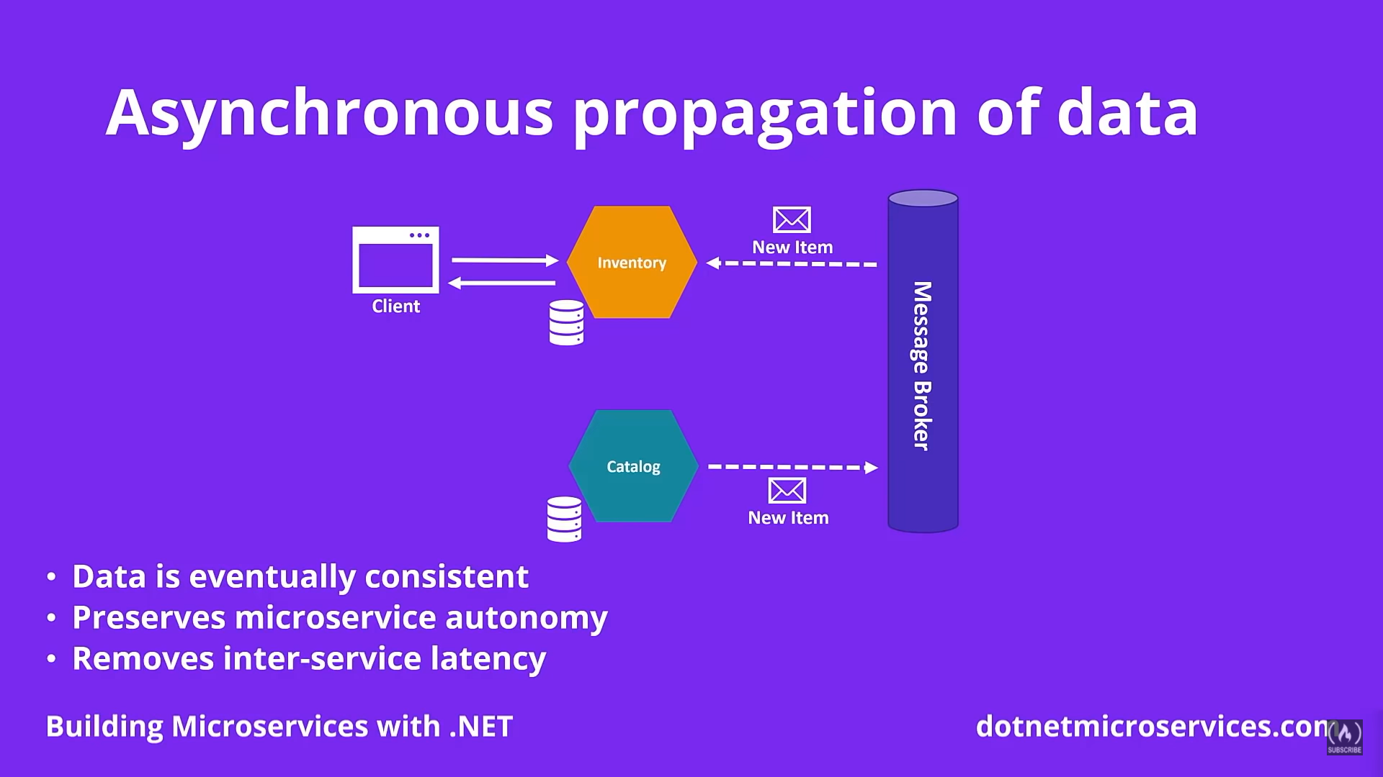

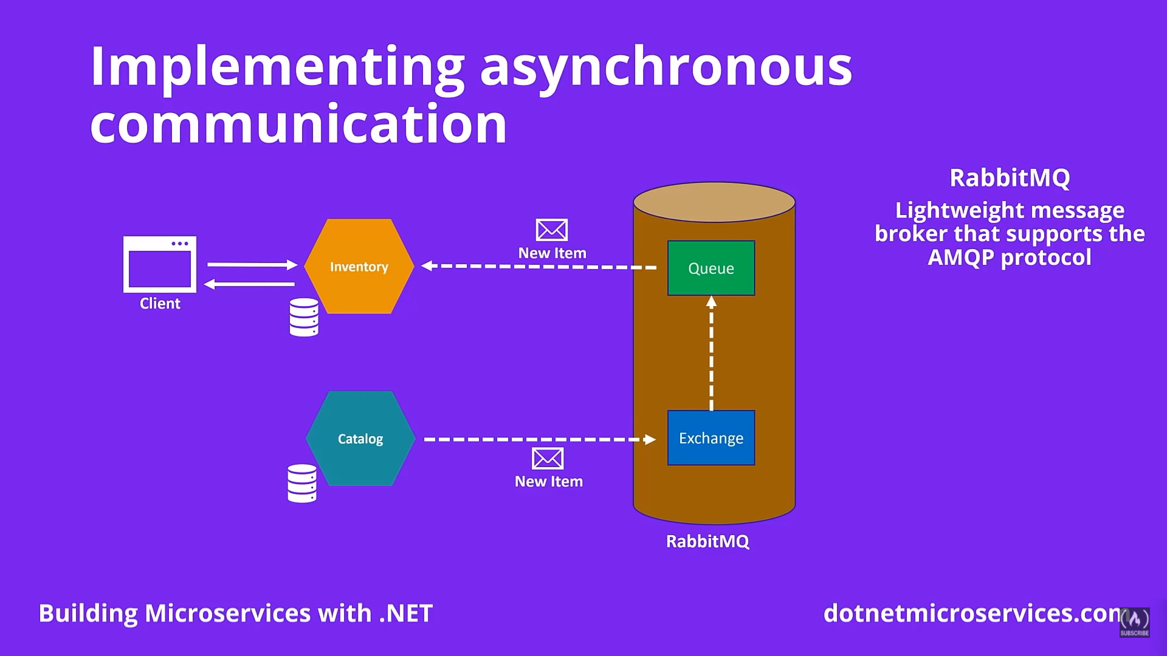

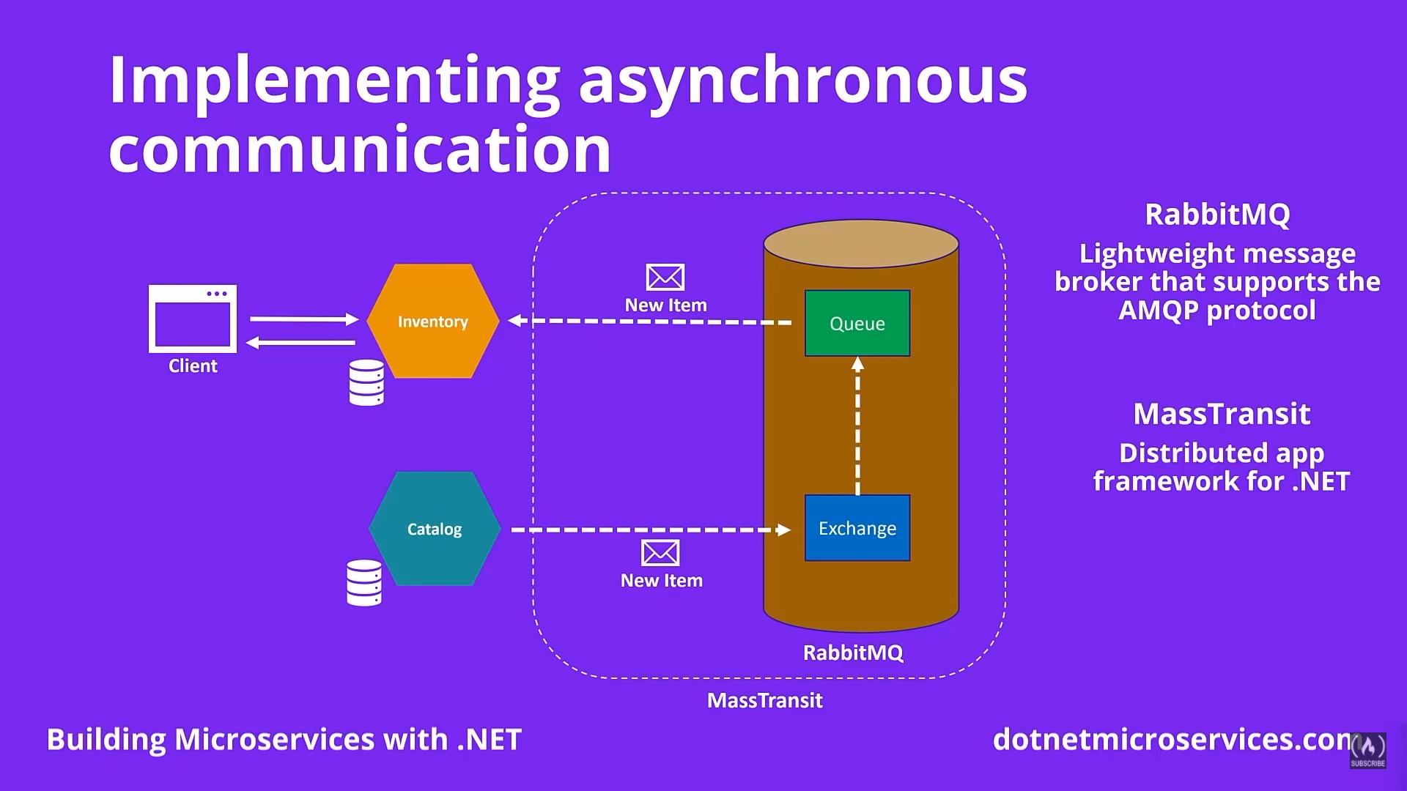

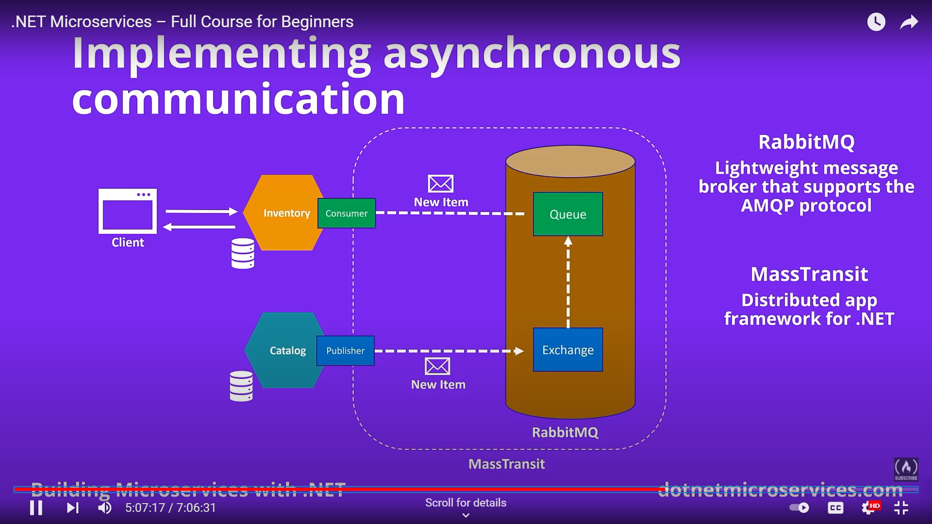

### **Defining the message contracts**

### **Publishing messages via MassTransit**

### **Standing up a RabbitMQ docker container**

### **Refactoring MassTransit configuration into the reusable NuGet package**

### **Consuming messages for eventual data consistency**

### **Removing the inter-service synchronous communication**